National Injury Prevention Day: Nov 18th
Safety Topic #1: Children & Gun Safety
- Firearms are the 2nd leading cause of death for children under age 18 in the United States.
- While the vast majority of these gun deaths are homicides and suicides, unintentional shootings—which make up 5% of annual gun deaths among children 18 & younger—are a persistent & heartbreaking aspect of this public health crisis.
- They are also preventable when families take the steps to reduce children’s access to firearms in their own homes and the homes of anywhere children are visiting.
- The 2 age groups most likely to be both shooters and victims were teenagers 14 to 17 first, and then preschoolers five and younger.
- From January 1, 2015, to December 31, 2020, there were at least 2,070 unintentional shootings by children resulting in 765 deaths & 1,366 nonfatal gun injuries.
- The number of unintentional deaths resulting from shootings by children from the start of the COVID-19 pandemic—March through December 2020—was a staggering 31% higher than that same period in 2019. ​In 2020 alone, at least 125 toddlers & pre-kindergarteners ages five & under shot themselves or someone else.

2 AGE GROUPS ACCOUNT FOR THE LARGEST SHARE OF BOTH SHOOTERS & VICTIMS: HIGH SCHOOLERS & CHILDREN FIVE AND YOUNGER
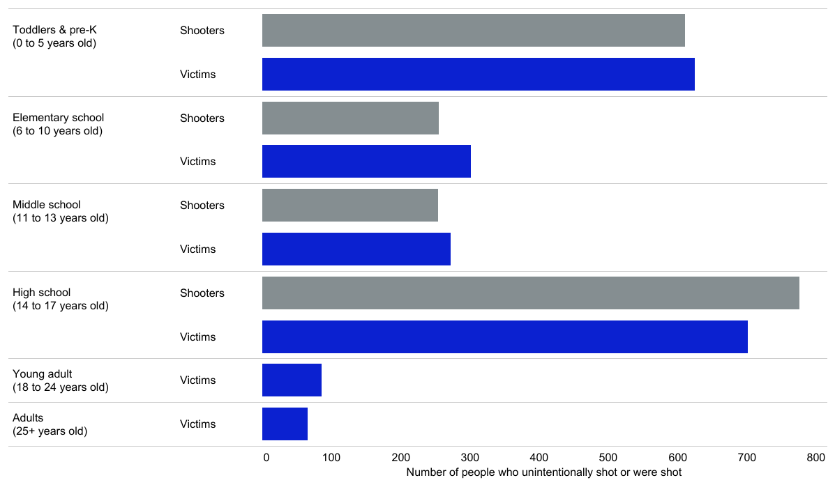
Preventable Tragedies: Findings from the #NotAnAccident Index | Everytown Research & Policy | Everytown Research & Policy
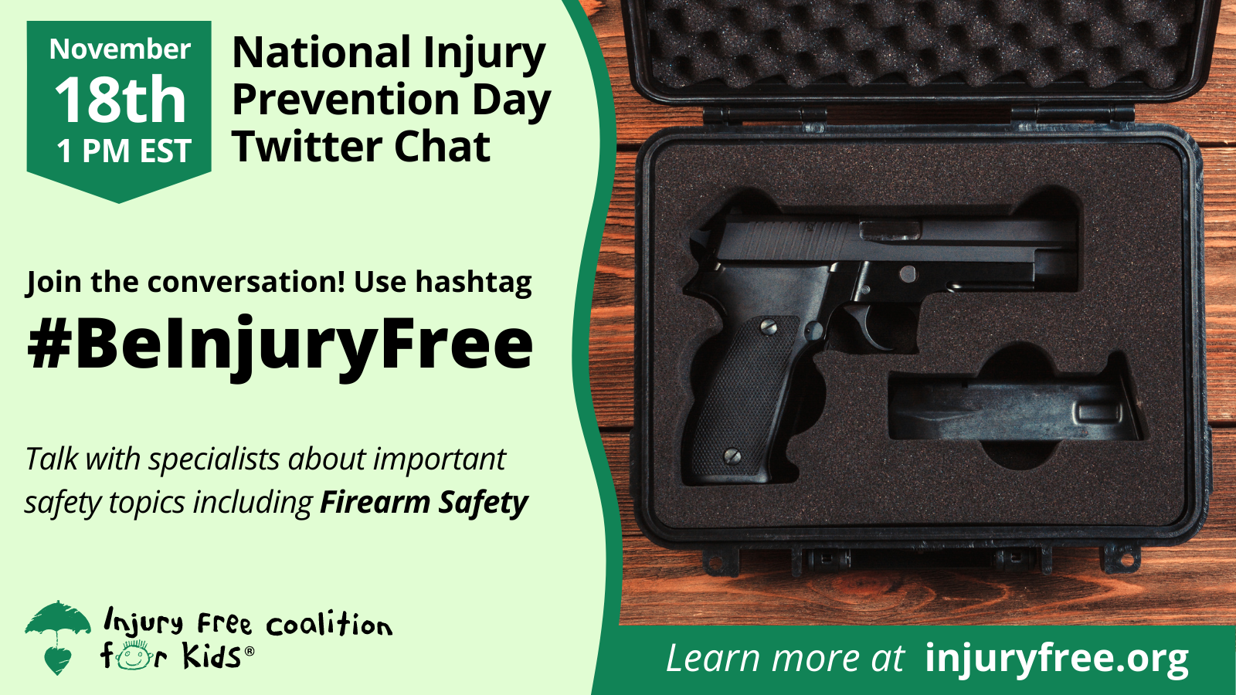

What is Sentara Williamsburg Regional Medical Center doing to promote National Injury Prevention Day….
- The water fountain lights and outside building lights will be shining green for all of November.
- Staff & visitors encouraged to wear green on Nov 18th.
- Safety topics & promotions of this day are being posted on Workplace, our social media pages, employee communications (Communicator & The Flash), posted in the elevators, & on the Peninsulas Emergency Management Services (PEMS) website.
- Please help us spread the word of this Day and spread the importance of Injury Prevention!
National Injury Prevention Day (injuryfree.org)
#BeinjuryFree

